Question 1: [9]

Create a web page with name **index.html** and a file style sheet with name **style.css** as belows:

*(****Note: using html5 and bootstrap (if possible))***

* Page size is 1000 pixel
* **Header** section (banner):

+ Height:80px, using background-image “overlay.png” and background-color “#db3b5d”

+ On the left: insert **h1** element with text “Colorized”

+ On the right: insert **span** element with text “Design by TEMPLATED”

+ Font color is #fff

* Nav section (menu):

+ Height:80px, using background “**#f8efcf**”

+ Insert links: Home page (index.html), Products (products.html), News (#) and Contact (contact.html)

+ Color’s links are “**#db3b5d**”, 16px, uppercase and not underlined

+ When mouse hover the link, background-color is “**#db3b5d**” and font color is “**#fff**”

* Advertisement section:

+ Insert image “**banner.jpg**”

* Content section:

+ The content is divided into 4 columns as shown

+ Content input from file **content.txt**

**+** Images: pics01.jpg, pics02.jpg, pics03.jpg, pics04.jpg

* Footer section

+ Using background-color “#2c2c2c”, height:80px, text-align:center

+ Insert text “Design by TEMPLATED” with color is “**#fff**”

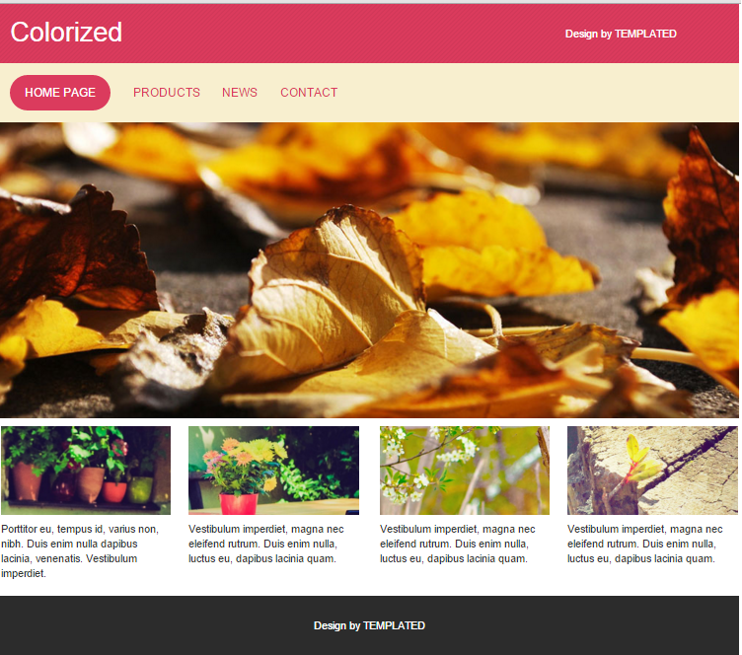

Question 2: [3]

Products.html page application interface as above and insert into the content area following:



In the content section insert Heading “Product”, and three small images **NokiaAsha503s.jpg, NokiaLumia2520s.jpg, NokiaLumia525s.jpg.**

When users click on the small images then display big images (the big images is: **NokiaAsha503.jpg, NokiaLumia2520.jpg, NokiaLumia525.jpg**)

Question 3: [8]

Contact.html page application interface as above and insert into the content area following form:

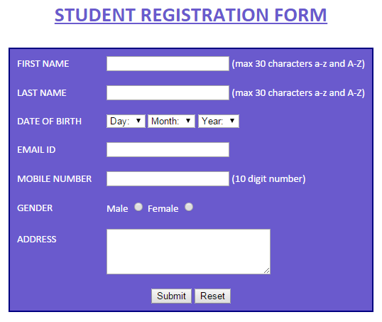

* Create a form as follows:

+ year of birth from 1980 to 2000

* When you click Submit, Validate the form as follows (using html5 attributes and javascript)

+ All the textbox is required

+ First name and last name is a maximum of 30 characters, including the letters a-z or A-Z

+ The date of birth must choose

+ Gender must choose

+ Email to a mail formed

+ Telephone number must contain 10 digits

* If the information is complete and accurate, the full display of the information that the user has registered